Statatistical Case-studies on Insurance Approval Time
Name
Institution-Affiliated

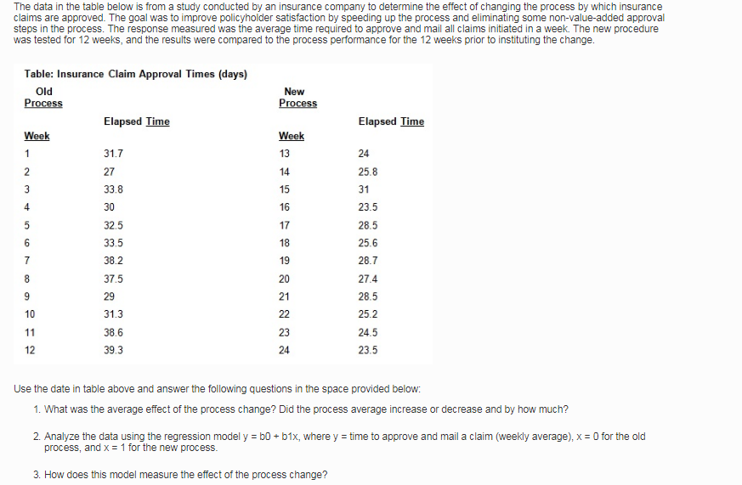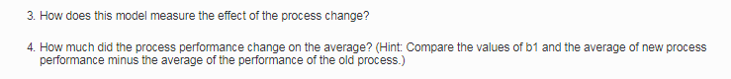
Question 1: average effect of the process
To determine the average effect of the process change, a Spearman Rank of Coefficient Correlation will be critical. A Spearman Rank of Coefficient Correlation demonstrates the difference of deviation after ranking the corresponding observations in the two processes, which are the old and the new process-performance. The Spearman Rank of Coefficient Correlation depicts the corresponding observation of the new and old performance-processes in an ascending or descending order
Solution:
Step 1; let the old performance process outcome of the elapsed time be X₀ ,
The elapsed time from the new performance process will be represented by X₁
The Spearman Rank Coefficient Correlation is;
$\frac{1-6∑D2}{n\left(n2-1\right)}$ = R_{s}
Where, D (Difference of Deviation after ranking the corresponding observations) =R _{X0} - R _{X1}
Step 2; interpretation of correlation coefficient
First, when R_{s} = 1, the observation exhibits a perfect positive correlation
Second, when 0.75≤R_{s} ≤1 , the observation has a strong positive correlation
Third, when 0≤R_{s} ≤0.25 , the observation has a weak positive correlation
Fourth, when R_{s}=0, the observation lack correlation
Five, when R_{s} =-1, perfect negative correlation exists
Step 3; we square the correlation of coefficient to result in Coefficient of Determinant (R²)
Table 1: Coefficient of Determinant
Time of week | Old process (X₀) | New process  (X₁) | Rank of  (X₀) | Rank of  (X₁) | Difference of Deviation (X₀ - X₁) | D²
1 | 31.7 | 24.0 | 5 | 3 | 7.7 | 59.29
2 | 27.0 | 25.8 | 1 | 7 | 1.2 | 1.44
3 | 33.8 | 31.0 | 8 | 12 | 2.8 | 7.74
4 | 30.0 | 23.5 | 3 | 1 | 6.5 | 42.25
5 | 32.5 | 28.5 | 6 | 9 | 4.0 | 16
6 | 33.5 | 25.6 | 7 | 6 | 7.9 | 62.41
7 | 38.2 | 28.7 | 11 | 11 | 9.5 | 90.25
8 | 37.5 | 27.4 | 10 | 8 | 10.1 | 102.01
9 | 29.0 | 28.5 | 2 | 9 | 0.5 | 0.25
10 | 31.3 | 25.2 | 4 | 5 | 6.1 | 37.21
11 | 38.6 | 24.5 | 12 | 4 | 14.1 | 198.81
12 | 34.3 | 23.5 | 9 | 1 | 10.8 | 116.64
$$∑$$ |  |  |  |  | 81.2 | 734.3

$$rs= \frac{1-6∑D2}{n\left(n2-1\right)}$$
$rs= \frac{1-6∑734.3}{10\left(100-1\right)}$
$$rs= \frac{3671.5}{990}$$
$rs= 3.7$(Perfect positive correlation)
Therefore, the average effect of process change for the company was 81.2 saving on the elapsed time taken to clear an insurance claim. Further, the process change yielded a X3.7 (times) increases in saving with the new performance system demonstrating significant effectiveness compared to the old module.
Question 2: Regression Interpretation
A regression model reveals two types of variables in an observation. The dependent variables and the independent elements are the profound parameters in a regression model, which quantifies the variability involved in an equation. Therefore, a general tendency is that both variables move together in the observation. The regression model is also called the Line of Best Fit using a formula$y=α ±βx$, where $α is the y=intercept$
$β=$is the slope of the gradient
$$Y=is the independent variable$$
X=is the dependent elements
Therefore, given the regression model Y= bo +bX₁
The above regression formula can be equated with the data Y= 81.2 + 3.7X₁ , to demonstrate a Stochastic Function. The Stochastic Function can be interpreted that every changes in new performance process yields a significant improvement of 3.7 with a constant 81.2 minutes taken to complete a claim order.
Question 3: Measure of Process Change
The Stochastic function Y= 81.2 + 3.7 X₁ can be used to predict the level of process changes by substituting the X1 with every new system. Hypothetically, using the new time taken in week 13 to 17, it is possible to determine/predict the overall period taken to complete each claim.
Y= 81.2 + 3.7 X₁
Table 2: Sample of Process Change using the Stochastic Equation Y= 81.2 + 3.7 X₁
Week | 13 | 14 | 15 | 16 | 17
Elapsed time | 24 | 25.8 | 31 | 23.5 | 28.5
New system time using the Stochastic Function | 120  {81.2+ (3.7*24)} | 177  {81.2+ (3.7*25.8)} | 196  {81.2+ (3.7*31)} | 168  {81.2+ (3.7*23.5)} | 187  {81.2+ (3.7*28.5)}

Question 4: Quantity of Process Performance Change
Table 1 above demonstrates the process performance had positive effects because of the reduction in time take to complete a claim from the previous systems. Therefore, the inverse of the summation of Difference of Deviation (X₀ - X₁) reveals 81.2 minutes saved with the introduction of a new performance process .

